SBDD State Summary Instructions
This document describes the steps needed to run the SBDD State Summary tool, create the summary results and analyze the summary for potential errors and issues in data.

Running the tool
Running the tool is very easy. The SBDD_Summary tool was developed as an ESRI ArcGIS toolbox for version 10.0. The tool was developed in python. In order to run the tool, you need the following things:
- Place the <tool>.tbx file and the SBDD_Summary.py file in the same directory;
- Place the SBDD Transfer data model (e.g. ESRI File geodatabase) in a drive, preferably on a local file directory;
- An ArcInfo license (version 10.0)

To run the tool, first add the SBDD_Summary tool box to an ArcCatalog; the SBDD_Summary.py script will automatically be added along with the tool. Run the tool by double clicking on the script. You will need to enter three arguments;
- The National Broadband Map feature dataset inside the Transfer data model file geodatabase, including the full path name;
- The two letter state abbreviation for the state data you are submitting (e.g. CA)
- The output folder to which the summary will be written (named <abbreviation>_<year>_<month>_<day>.csv.

After you have entered the arguments (see image below for an example), click the ok button on the tool. The output dialog will inform the user it is writing a total of 10 pages of summary statistics. Expect the tool to take 15 to 20 minutes to run.

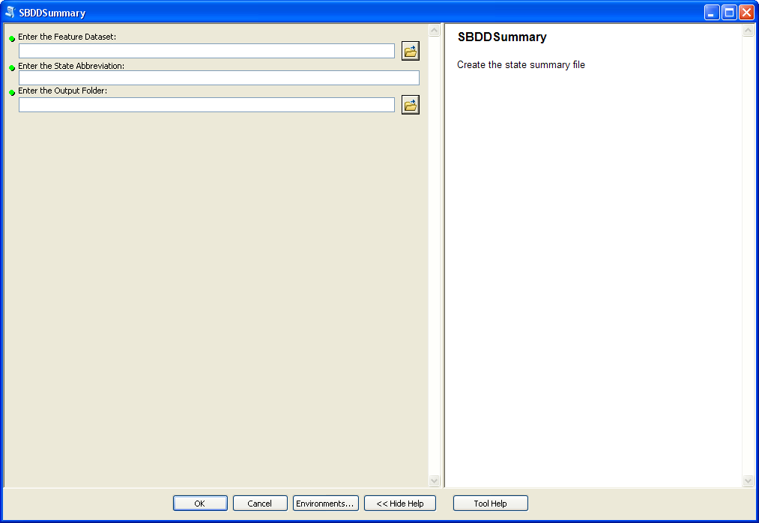

Preparing the results
The tool finishes by writing a .csv file (comma separated value) to the output folder you entered in the argument. The name of the file is <abbreviation>_<year>_<month>_<day>.csv. (e.g. CA_2011_05_13.csv).

Additionally, the FCC has prepared a template file (named Template SBDD Submission Summary.xls) upon which reads the resulting csv file and formats the results. You will need to copy the results of the csv file and paste them into the Template file to view the fully formatted results. To accomplish this, perform the following steps;
- Open the .csv file in MS Excel
- Open the template file in MS Excel
- Copy then entire results of the .csv file by right clicking in the upper left hand cell at the intersection of Column A and Row 1 and selecting copy as shown in the image below.

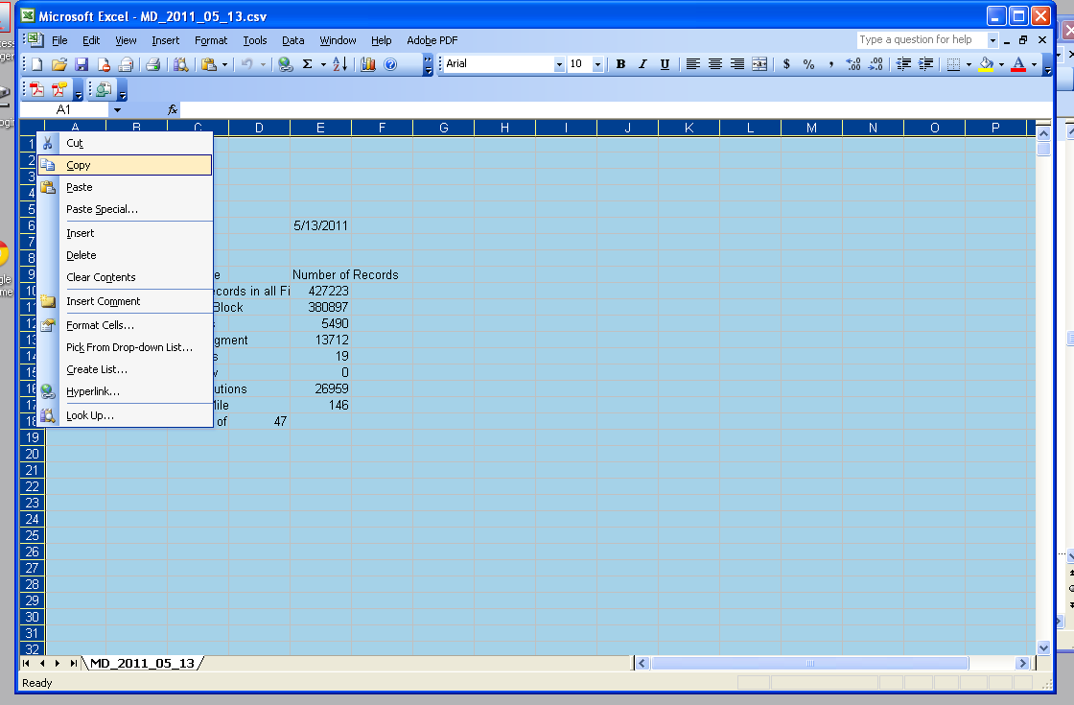

- Paste the entire results in Column A Row 1 of the ‘Data’ worksheet in the Template .xls file as showing in the image below.

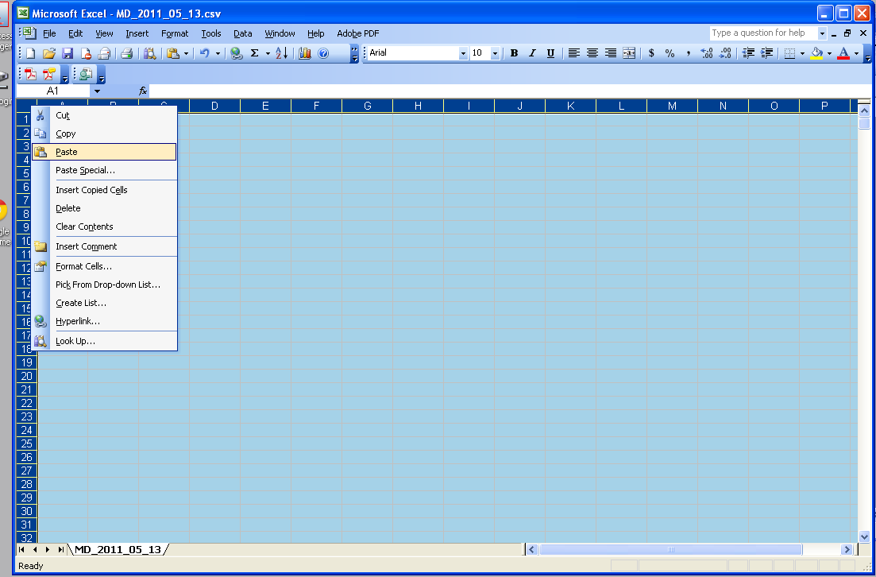

- Your two letter state abbreviation should now be in Row 2 Column A.
- The ‘Submission Summary’ worksheet is automatically calculated off of the information in the newly pasted in ‘Data’ worksheet.
- Rename the ‘template’ xls file, by removing the word template in the title and replacing it with your two letter state abbreviation so the file (e.g. CA SBDD Submission Summary.xls)
- Open the ‘Submission Summary’ worksheet and analyze it for issues.

Analysis of the Summary
Below are detailed lists of issues you should look at for your state summary to ensure quality in the data.

